Assignment 1

Create table SALESFORCE and insert sample data into SALESFORCE :

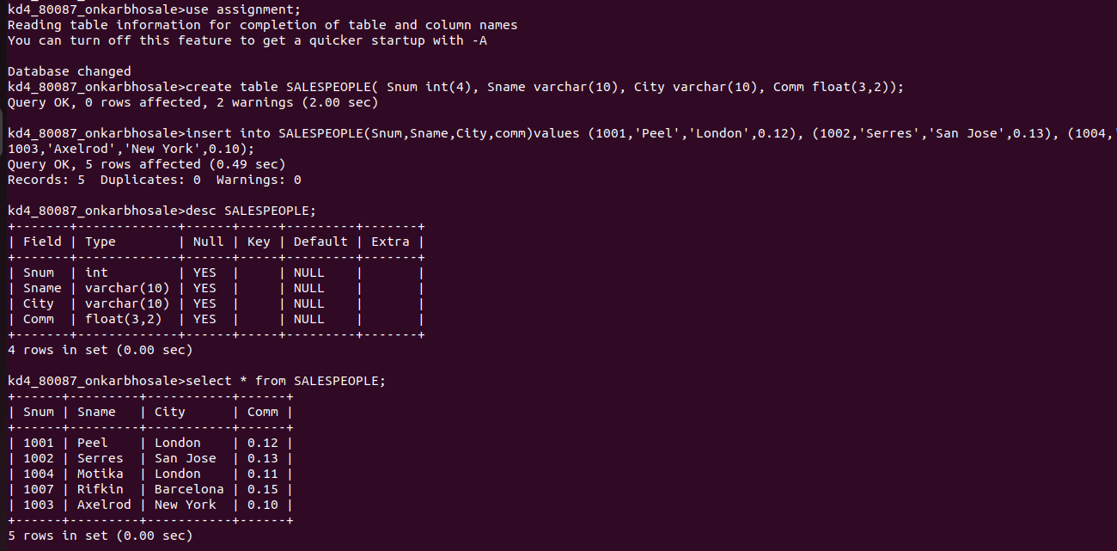

Create table ORDERS and insert sample data in ORDERS :

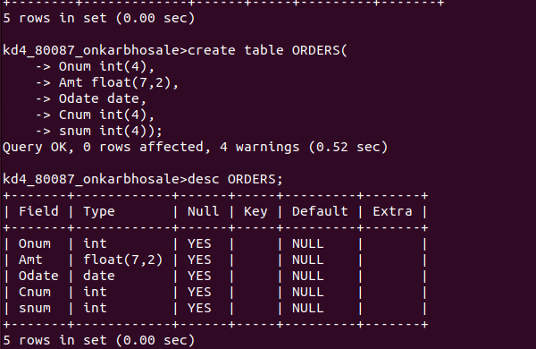
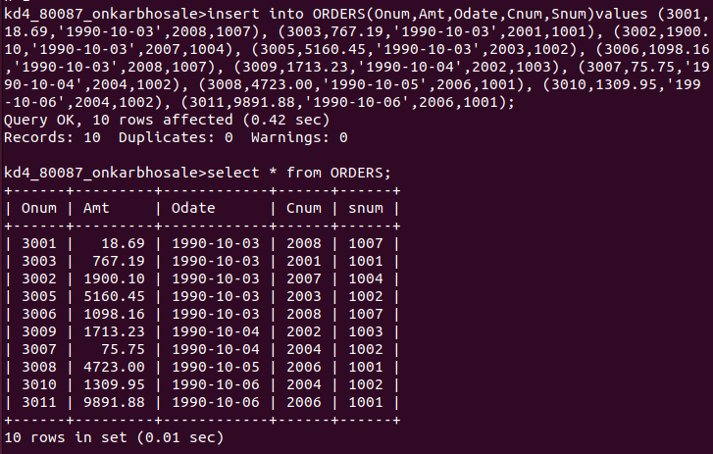

Create table CUSTOMERS and insert sample data into CUSTOMERS :

